

**YEAR 12 HUMAN BIOLOGICAL SCIENCE**

**ATAR Semester Two Examination 2017**

**Question/Answer Booklet**

**ANSWERS**

**Time allowed for this paper**

Reading time before commencing work: 10 minutes

Working time for paper: 3 hours

**Materials required/recommended for this paper**

***To be provided by the supervisor***

This Question/Answer Booklet

Multiple-Choice Answer Sheet

Two Extended Answer Booklets

***To be provided by the candidate***

Standard items: pens (black/blue preferred), pencils (including coloured), eraser, correction fluid/tape, ruler, highlighters, sharpener

Special items: non-programmable calculators satisfying the conditions set by the School Curriculum & Standards Authority for this course

**Important note to candidates**

No other items may be taken into the examination room. It is **your** responsibility to ensure that you do not have any unauthorised notes or other items of a non-personal nature in the examination room. If you have any unauthorised material with you, hand it to the supervisor **before** reading any further.

**Structure of this paper**

|  |  |  |  |  |  |  |
| --- | --- | --- | --- | --- | --- | --- |
| Section | Number of questions available | Number of questions to be answered | Suggested working time (minutes) | Marks available | Percentage of exam | Mark |
| Section One:  Multiple- choice | 30 | 30 | 30 | **30** | **30** |  |
| Section Two:  Short answer | 10 | 10 | 90 | **100** | **50** |  |
| Section Three:  Extended answer | 3 | 2 | 60 | **40** | **20** |  |
|  |  |  |  | **TOTAL** | **100** |  |

**Instructions to candidates**

**Instructions to candidates**

1. The rules for the conduct of Western Australian external examinations are detailed in the *Year 12 Information Handbook 2017.* Sitting this examination implies that you agree to abide by these rules.

2. Answer the questions according to the following instructions.

Section One: Answer all questions on the separate Multiple-choice Answer Sheet provided. For each question shade the box to indicate your answer. Use only a blue or black pen to shade the boxes. If you make a mistake, place a cross through that square, do not erase or use correction fluid, and shade your new answer. Marks will not be deducted for incorrect answers. No marks will be given if more than one answer is completed for any question.

Sections Two: Write answers in this Question/Answer Booklet.

Section Three: Write each extended response in a separate answer book.

3. You must be careful to confine your responses to the specific questions asked and to follow any instructions that are specific to a particular question.

4. Spare pages are included at the end of this booklet. They can be used for planning your responses and/or as additional space if required to continue an answer.

* + Planning: If you use the spare pages for planning, indicate this clearly at the top of the page.
  + Continuing an answer: If you need to use the space to continue an answer, indicate in the original answer space where the answer is continued, i.e. give the page number. Fill in the number of the question(s) that you are continuing to answer at the top of the page.

**SECTION ONE: Multiple-choice 30 MARKS (30%)**

This section has **30** questions. Answer **all** questions on the separate Multiple-choice Answer Sheet provided. For each question shade the box to indicate your answer. Use only a **blue or black pen** to shade the boxes. If you make a mistake, place a cross through that square, do not erase or use correction fluid, and shade your new answer. Marks will not be deducted for incorrect answers. No marks will be given if more than one answer is completed for any question.

Suggested working time: 40 minutes.

1. Which of the following statements is INCORRECT regarding the strata below?

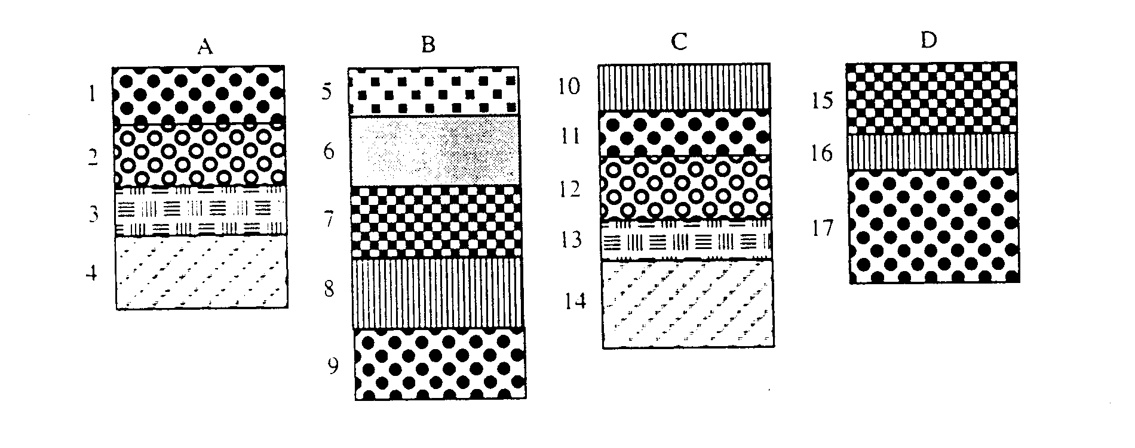

* 1. A1 is the same age as B9
  2. D15 is older than B6
  3. A4 is the same age as C14
  4. B8 is younger than D15

1. Regulation of the nervous system is different from that of endocrine regulation in that the nervous system
   1. is quick, precise and localised
   2. is slower and more penetrative
   3. has longer lasting effects
   4. does not require conscious activity
2. A patient with symptoms of fluctuating body temperature, intense thirst and insomnia is likely to have a dysfunction of the
   1. medulla oblongata
   2. hypothalamus
   3. pituitary gland
   4. cerebellum
3. During repolarization of the neurone membrane,
   1. sodium ions rapidly move to the outside of the cell
   2. sodium ions rapidly move to the inside of the cell
   3. potassium ions rapidly move to the outside of the cell
   4. potassium ions rapidly move to the inside of the cell
4. Which of the following lists of symptoms could indicate hypothyroidism?
   1. Unexplained weight gain or loss, slow heart rate, goitre
   2. Slow heart rate, fatigue, weight gain
   3. Unexplained weight loss, accelerated heart rate, fatigue
   4. Increased appetite, fatigue, sweating

**Refer to the diagram given below to answer Question 6.**

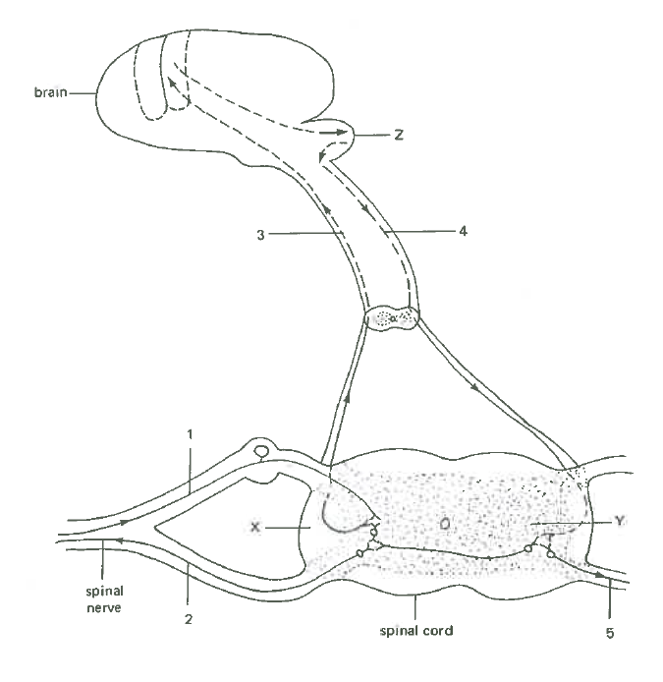

1. Determine which of the following neural pathways would belong in a reflex action.
   1. 1 🡪 2
   2. 3 🡪 4 🡪 5
   3. 1🡪 3 🡪 4 🡪 2
   4. 4 🡪 2
2. Abnormal production of anti-diuretic hormone (ADH) could result from the dysfunction of

the

* 1. anterior pituitary gland
  2. hypothalamus
  3. adrenal glands
  4. medulla oblongata

1. Which one of the following will result in an increased breathing rate?
   1. Increased oxygen levels detected by the hypothalamus
   2. Decreased carbon dioxide levels detected by the hypothalamus
   3. Stimulation of the chemoreceptors by increased carbon dioxide
   4. Stimulation of the sympathetic nerves to the lungs
2. Amine hormones
   1. enter the target cells through proteins channels
   2. diffuse into a cell through the phospholipid bilayer
   3. enter the target cell by active transport
   4. bind with the membrane receptors in order to affect a target cell
3. The grey matter of the central nervous system:
   1. Is found on the inside of the spinal cord and outside of the brain
   2. Is found on the outside of the spinal cord and inside of the brain
   3. Is made up mainly of cell bodies and is on the inside of the brain
   4. Is made up mainly of cell processes and is on the outside of the spinal cord
4. When the body fails to distinguish self from non-self antigens, this leads to ___________.
   1. tissue rejection
   2. hypersensitivities
   3. allergies
   4. autoimmune disorders
5. The main components of the immune response involved in organ rejection are
   1. red blood cells, white blood cells and antigens
   2. T cells, B cells and red blood cells
   3. antibodies, T cells and B cells
   4. antibiotics and white blood cells
6. What role do mucous membranes and cilia play in the body’s first line of defence against pathogens?
   1. They cause cell death to cut off pathogens
   2. They form part of a barrier preventing pathogens from entering
   3. They remove pathogens as part of the inflammatory response
   4. They recognise pathogens passing through the lymphatic system
7. In haemoglobin, the amino acid sequence of the beta (ß) polypeptide chains differs among the species which possess the molecule. The beta chains of the species shown in the table below were analysed. The number of amino acid differences between humans and each of the species was counted and ranged between 8 and 127.

Which of the following would be consistent with the proposed evolutionary relationships between each of the organism and humans?

|  |  |  |  |  |  |
| --- | --- | --- | --- | --- | --- |
|  | **Amino acid differences** | | | | |
| dog | earthworm | frog | lamprey | Rhesus monkey |
| a. | 15 | 127 | 67 | 125 | 8 |
| b. | 67 | 15 | 127 | 8 | 67 |
| c. | 125 | 8 | 67 | 15 | 127 |
| d. | 127 | 125 | 8 | 67 | 15 |

1. Which of the following is an example of passive natural immunity?
   1. The body manufactures antibodies in response to an invading pathogen
   2. Antibodies enter the blood stream via an injection of antitoxin
   3. Antibodies enter the blood stream from mother to foetus across the placenta
   4. The body manufactures antibodies after an injection of toxoids
2. The Amish population of Eastern Pennsylvania started as a small number of German immigrants, about 200 individuals. The Amish carry an unusually high frequency of a number of inherited disorders, such as dwarfism (Ellis-van Creveld syndrome), polydactyly (extra fingers or toes), abnormalities of the nails and teeth, and in about half of the individuals, a hole between the two upper chambers of the heart. The most likely explanation for the Amish population to experience high frequency of these disorders is
   1. the founder effect
   2. geographical isolation
   3. natural selection
   4. speciation

**Refer to the diagram below to answer Question 17.**

**C**

**G**

**T**

**A**

**C**

1. The sequences of bases in the fully-assembled DNA strand would read
   1. CGTAC
   2. CATGC
   3. CTCAG
   4. GATCC

**Refer to the following diagram to answer Question 18.**

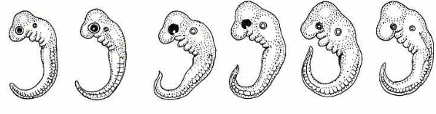

1. The diagram above shows all the early embryos of vertebrates which are characterised by the absence of paired appendages and the presence of a well-developed tail. Which of the following supports the theory of evolution?
   1. They all have features that are characteristic of their species
   2. They all have features that do not occur in the adult form
   3. All features of the adult form can be recognised in the embryo
   4. None of the features at the embryonic stage is typical of modern vertebrates
2. The age of the Earth and its inhabitants has been determined through two complementary lines of evidence; namely
   1. relative dating (eg. stratigraphy) and absolute dating (eg. radio-isotope dating)
   2. absolute dating (eg. stratigraphy) and relative dating (eg. radio-isotope dating)
   3. absolute dating (eg. index fossils) and relative dating (eg. stratigraphy)
   4. absolute dating (eg. index fossils) and relative dating (eg. radio-carbon)

**Refer to the diagrams below to answer Question 20 and 21.**

|  |  |
| --- | --- |
| **P** | **Q** |
| **R** | **S** |

1. Which of the following describes the correct order of the hominin skulls from the earliest to the most recent?
   1. S R Q P
   2. R S Q P
   3. R P S Q
   4. R S P Q

1. Choose the hominin (P Q R S) who made the tools as shown in the diagram above.

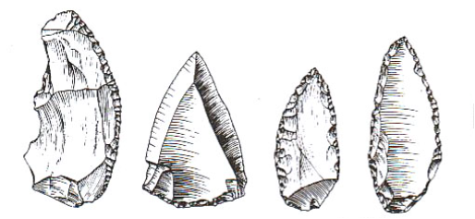

a. Hominin P

b. Hominin Q

c. Hominin R

d. Hominin S

1. Hormone replacement therapy was used to treat a patient who suffered from low levels of salt in his blood. Identify the hormone used for this treatment.

* 1. aldosterone
  2. thymosins
  3. parathyroid hormone
  4. insulin

1. A mineralised remnant of a primate skull, believed to be several million years old, is brought into the lab for dating. Which of the following suggests the best reason why carbon-14 dating may not be a useful technique?

a. Too little carbon content is present.

b. The ratio of carbon-14 to carbon-12 in the atmosphere is variable.

c. Carbon-14 has a relatively short half-life.

d. The radioactive decay of carbon-14 is not consistent.

1. Which of the following roles best describes the function of cytotoxic T-cells?
   1. They are important in inflammatory responses and allergic reactions
   2. They are necessary for B cell activation
   3. They recognise antigens, bind to antigens and produce antibodies to counteract cancerous cells or virus infected cells
   4. They are the main cells in the body’s cell-mediated immune response

**Refer to the diagram below to answer Question 25.**

**Nervous System**

**Central Nervous System**

**1**

**Afferent**

**Efferent**

**2**

**Brain**

**3**

**4**

**Autonomic**

**Sympathetic**

**5**

1. Which of the following correctly identifies each of the missing components of the nervous system?

|  |  |  |  |  |  |
| --- | --- | --- | --- | --- | --- |
| **Component** | **1** | **2** | **3** | **4** | **5** |
| a. | Peripheral  Nervous System | Spinal cord | Parasympathetic | Sensory | Sensory |
| b. | Peripheral  Nervous System | Spinal cord | Sensory | Somatic | Parasympathetic |
| c. | Peripheral  Nervous System | Spinal cord | Sensory | Parasympathetic | Somatic |
| d. | Somatic Nervous System | Peripheral  Nervous  System | Spinal cord | Sensory | Parasympathetic |

1. Which of the following is unlikely to occur when the core body temperature begins to fall?
   1. vasoconstriction of the arterioles in the skin
   2. shivering
   3. increase in voluntary activity
   4. decrease in cellular metabolism
2. A fossilised femur was discovered in Kenya and was dated at 1.5 million years old. The soil conditions that would have **best** allowed for fossilisation of these remains would be:
   1. dry and acidic soils, low in oxygen
   2. wet and acidic soils, low in oxygen
   3. dry and alkaline soils, low in oxygen
   4. wet and alkaline soils, low in oxygen
3. Bioinformatics is most appropriately defined as an area of biological science in which
   1. the genome sequences of different species can be compared through computational analysis
   2. the use of computers is instrumental to describe molecular components of living things
   3. the micro-structural features of related organisms can be compared and analysed
   4. the biochemical techniques of sequencing amino acids can be computed and the degree of similarity can be established
4. *Staphylococcus aureus* is a bacterium that is a common cause of skin infections. It was previously killed by the antibiotic methicillin. However, a strain of *Staphylococcus aureus* is now resistant to this antibiotic.

Which of the following statements **best** explains how methicillin-resistant *Staphylococcus aureus* originated?

* 1. Methicillin directly caused mutations in the bacterial DNA, resulting in some bacteria that were resistant to the drug.
  2. Changes in the bacterial DNA sequence by chance produced a strain resistant to methicillin
  3. Bacteria with resistance to methicillin survived due to natural selection
  4. Genetic drift caused more bacteria with resistance to survive, creating a methicillin-resistant population

1. The term ‘carrying angle’ refers to the
   1. Forward tilt of the body of most primates during bipedal or quadrupedal locomotion
   2. Angle created between the long axis of the femur and the vertical axis
   3. Orientation of the foramen magnum to the vertical axis of the skull of most primates
   4. Forward tilt of the pelvis during bipedal locomotion

**END OF SECTION ONE**

**SECTION TWO: Short Answer 100 MARKS (50%)**

This section has nine **(9)** questions. Answer **ALL** questions. Write your answers in the space provided.

Spare pages are included at the end of this booklet. They can be used for planning your responses and/or as additional space if required to continue an answer.

* Planning: If you use the spare pages for planning, indicate this clearly at the top of the page.
* Continuing an answer: If you need to use the space to continue an answer, indicate in the original answer space where the answer is continued, i.e. give the page number. Fill in the number of the question(s) that you are continuing to answer at the top of the page.

Suggested working time for this section is 90 minutes.

**Question 31 (13 marks)**

The diagram shown below is an illustration of a motor neuron.

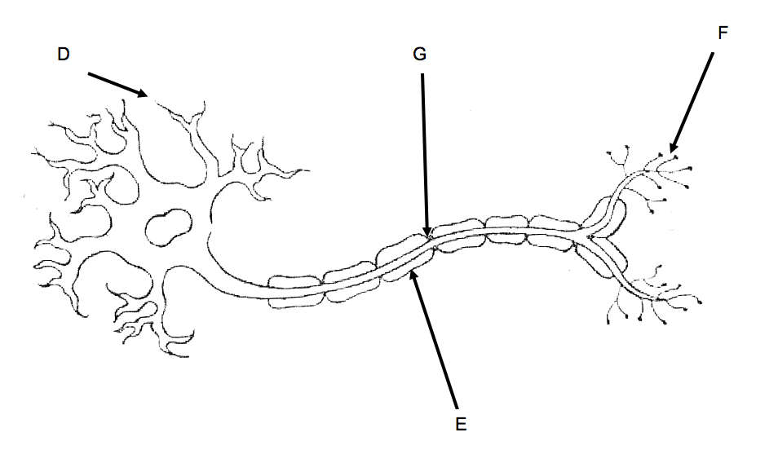

1. In terms of normal function, what is the role of the structures labelled D, E and F.

|  |  |
| --- | --- |
| STRUCTURE | ROLE IN MOVEMENT |
| D | Carries nerve impulse into the cell body (1) |
| E | Speeds up the nerve impulse (1) |
| F | conducts electrical signals to a nerve synapse (1) |

(3 marks)

1. A student researching the term ‘Saltatory Conduction’ stated that the region in the motor neuron labelled G experiences depolarisation.
   1. What is meant by the term saltatory conduction?

Conduction of a nerve impulse along a myelinated nerve fibre - impulse jumps from 1 node of ranvier to the next (1)

* 1. Describe the events that occur during depolarisation of a neuron.
* If a sufficiently strong stimulus is applied to a nerve fibre, the membrane becomes more permeable to sodium ions (1)
* Sodium ions move across the membrane and into the cell (1)
* This inward movement is too great to be balanced by an outward movement of potassium ions & the membrane becomes depolarised (1)

(4 marks)

1. In terms of normal neuron function, what is the significance of the refractory period?

Short period following a stimulus during which a nerve cell / muscle fibre cannot be stimulated again / impulse in one direction (1)

(1 mark)

1. Outline the events in the transmission of impulse from one neuron to another across a synapse.

* When an action potential reaches synaptic knob, there is an opening of Ca2+ gated channels, vesicles containing neurotransmitter fuse with membrane & is released (1)
* Neurotransmitters diffuse across synaptic cleft/gap (1)
* Neurotransmitters bind to receptor molecules on post-synaptic neuron (1)

1. marks)
2. Explain why the neural pathways of reflex arcs have very few synapses.

* Information passes across synapses relatively slowly compared to the speed it passes along an axon (1)
* Fewer the synapses, the shorter the overall time taken to respond to a stimulus – an advantage where a rapid response is required (1)

(2 marks)

**Question 32 (10 marks)**

A carpenter pricked his finger on a rusty hook on a broken door. Soon after he noticed that the injured finger was red and swollen. Sometime later, he felt a throbbing sensation in his arm. Later in the day, he was unwell, running a high fever, broke out in a cold sweat and had to take the rest of the day off work. His doctor prescribed him a course of antibiotics.

1. Apart from fever, identify and explain the defence mechanisms used by the body in response to the injury.

* Inflammatory response (1)
* Finger becomes inflamed (red & swollen) to allow more blood to flow into area / Histamine also increases blood flow through the area (1)
* Blood brings more phagocytes to the area to destroy pathogens from the rusty hook (1)
* Swelling & pain reduces movements / helps confine pathogens in the area (1)

(4 marks)

1. What are two (2) ways in which antibiotics can act to fight the infection?

* Bactericidal – kill bacteria by changing the structure of the cell wall/membrane (1)
* Bacteriostatic – stops bacteria from reproducing (1)

(2 marks)

1. Describe the thermoregulatory mechanisms that occur during and immediately after a fever.

* Pyrogens / substances in bacteria & viruses signal the hypothalamus to increase body temperature (1)
* Feels cold/shivering to generate heat; & peripheral blood vessels constrict so skin is pale (1)
* Body temp will continue to increase until it reaches the new higher set-point of the hypothalamus (1)
* Once all pathogens are eliminated, fever is broken & shivering stops / vasodilation & sweating works to cool body back to normal temperature range (1)

(4 marks)

**Question 33 (12 marks)**

According to the WA’s Health Minister John Day and former Federal Health Minister Sussan Ley, meningococcal outbreaks in Western Australia since early 2016 necessitated a nationwide vaccine program before winter of 2017. Meningococcal disease is a life-threatening disease caused by different strains of the bacterium *Neisseria meningitidis*. Commonly found in the upper respiratory tract of infected people, the bacterium is spread through coughing, sneezing or close contact with infected people, causing blood poisoning and meningitis.

It was also reported that Perth toddler Robbie Buchan lost most of his four limbs after he contracted the B strain of meningococcal. Each injection of the B strain vaccine costs about $150 and babies under one year of age need up to three injections. The B strain vaccine is undergoing a global shortage and limited supplies meant availability would be delayed for a while. While there are more cases of the W strains of the disease, there are efforts to make the vaccines for both B and W strains more accessible to the public.

1. Suggest a reason why vaccines are required for all babies at birth and at the age of two, four and six months.

* Mothers antibodies do not provide reliable protection / no natural immunity for common viruses
* Repeat exposure – increase memory cells

(any 1)

(1 mark)

1. Outline the response of B lymphocytes to the meningococcal vaccine.

* Once a B-lymphocyte binds with its specific antigen, it needs to be activated by a helper T cell (1)
* Once activated, it divides rapidly, producing plasma cells & memory cells (1)
* Plasma cells produce & secrete huge quantities of antibodies / while the memory cells keep copy of the shape of the pathogen (1)

(3 marks)

1. Explain how a routine vaccination for meningococcal may cause a decrease in the incidence of this disease in Western Australia for both the individual and the community.

* Immunisation of an individual provides them with active immunity (1)
* Secondary response – if bacterium is encountered again, it is destroyed before the disease symptoms appear (1)
* Immunisation provides herd immunity. Fewer potential sufferers mean it is more difficult for the disease to spread (1)
* Immunisation may reduce the number of unaffected carriers by stimulating their immune system to produce antibodies (1)

(4 marks)

1. Why is the B meningococcal vaccine unable to provide protection against other strains of the same bacterium?

* Different strains have different surface antigens (1)
* Antibodies & memory cells produced in response to vaccination are specific to the antigens on the surface of the bacterium. They are ineffective against other antigens (1)

(2 marks)

1. Describe one socio-cultural and one economic factor that influence whether or not parents

choose to have their children immunised.

* Economic – cost of visiting a doctor / cost of the vaccine / priorities of government (1)
* Socio-cultural – perceived health concerns & side effects of vaccine / lack of availability or access to vaccine / ethical or religious objection to medical intervention (1)

(2 marks)

**Question 34 (9 marks)**

Tay-Sachs disease is a disorder of lipid metabolism which occurs as a result of a gene mutation. The recessive allele prevents the gene from producing a protein that will be able to function in the body. These recessive mutations are considered `lethal recessives’, and in the case of Tay-Sachs disease, this can lead to the death of the embryo or foetus, or early death of a child.

1. Distinguish between a gene mutation and a chromosomal mutation.

* Gene – change in a single gene so that the traits normally produced by the gene are changed or destroyed (1)
* Chromosomal – changes in all or part of the chromosome and affect not just one but a number of genes (1)

(2 marks)

1. Explain why Tay-Sachs disease is considered a lethal recessive condition.

* Recessive allele for TS not masked by a dominant normal allele (1)
* Mutant allele is lethal as it brings about a missing enzyme resulting in the accumulation of a fatty substance in the nervous system, results in an early death (1)

(2 marks)

1. Explain using the example of Tay-Sachs how a lethal recessive mutation can bring about changes in the gene pool through the two evolutionary mechanisms:
2. genetic drift

* As a fatal disease, its frequency worldwide is low, but is higher amongst the Ashkanazi Jews as their population is small & isolated (1)
* Small & isolated population increases chance of genetic drift – random, non-directional variation (1)

(2 marks)

1. natural selection

* While individuals with 2 normal alleles would be more susceptible to TB & would possibly die due to TB, while individuals with 2 TS alleles would die early in life (1)
* Heterozygotes would have increased resistance to TB & therefore have a survival advantage & would pass their alleles onto the next generation (1)
* Over time, gene pool would have more TS alleles / frequency of TS allele increases (1)

(3 marks)

**Question 35 (12 marks)**

The diagram below shows a cross section of the human brain.

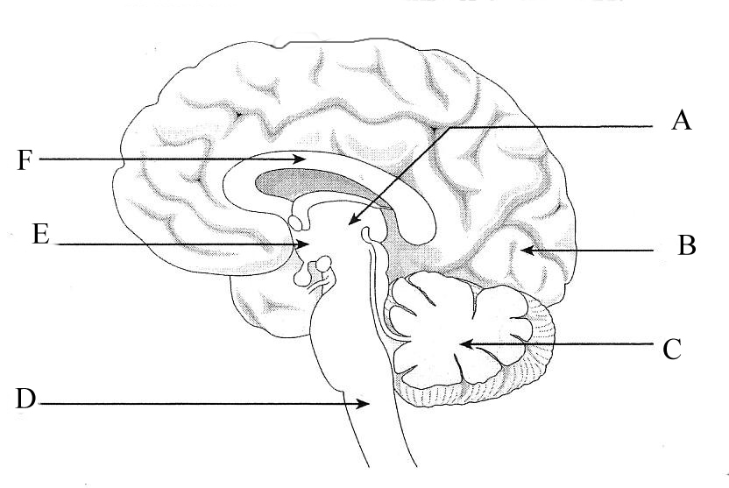

1. Label the following structures:

C: Cerebellum

E: Hypothalamus

(2 marks)

1. The brain is a very delicate organ and needs to be protected from damage by other structures that surround it. Name one (1) of these structures and explain how it protects the brain.

Cranium/skull – hardness of the cranium/encases brain

Meninges – outer layer is tough/inflexible – prevents the brain moving/inner layer is sealed so protects against infection

Cerebrospinal fluid – cushions/shock absorbs

Name (1) Explanation (1)

(2 marks)

***Refer to the diagram below to answer the following questions.***

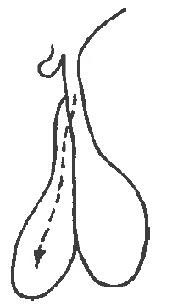Organ A 

Directly stimulates fat utilisation

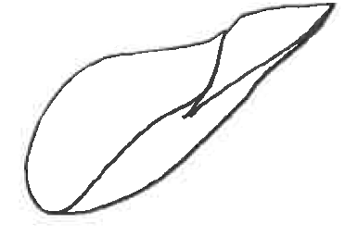

Metabolic Effects

Liver

1. Identify organ A which releases the growth hormone.

Anterior pituitary gland

(1 mark)

1. Explain how the two lobes of organ A are different with respect to their relationship with the hypothalamus.

* Anterior pituitary secretes / inhibits release of hormones in response to releasing or inhibiting factors / hormones from the hypothalamus (1)
* Posterior pituitary simply stores & releases neuro-hormones that originate in the hypothalamus neurosecretory cells / under neural stimulation (1)

(2 marks)

1. Describe the metabolic effects of growth hormone.

* Stimulates production of bone cells (chondrocytes) & development of bone tissue (1)
* Stimulates muscle growth through protein synthesis (1)

(2 marks)

1. Genetically engineered bacteria have been used to produce human growth hormone through a process called recombinant DNA technology.

Outline the steps involved in this process.

* Isolate human growth hormone using restriction enzyme & use same restriction enzyme to cut open a bacterial plasmid (1)
* Use DNA ligase to join the insulin gene into the plasmid (forming a recombinant DNA) (1)
* Treat bacteria so that they take up the recombinant DNA. Bacteria multiplies & produces human growth hormone (1)

(3 marks)

**Question 36 (11 marks)**

An experiment was carried out with two groups of people. Group A is the control group while Group B has type 1 diabetes. Every 15 minutes, blood samples were taken from all members of both groups and the mean concentrations of insulin, glucagon and glucose were determined. After one hour, each person was given a **glucose** drink. All results for the control group are shown in the graph below. Blood samples were taken every 15 minutes for the next 4 hours.

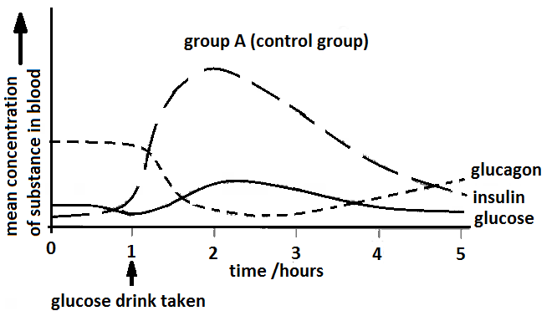

**Figure 9**

1. Describe two (2) symptoms that an individual with type 1 diabetes may experience prior to them being diagnosed.

Excessive thirst / unusually high levels of urination / feeling tired all the time / loss of muscular bulk & unexplained weight loss / blurring of vision (any 2 for 2 marks)

(2 marks)

1. Name the endocrine portion of the pancreas and the cell type that produces glucagon.

Alpha Cells in the Islets of Langerhans (must have both for 1 mark)

(1 mark)

1. Name two (2) hormones, other than insulin and glucagon, that are involved in regulating blood glucose concentration.

Adrenaline (1)

Glucocorticoids (eg. Cortisol) (1)

(2 marks)

1. Using the information from the graph on the previous page, explain how the body will return the blood glucose level to a normal limit if it rises.

* Beta cells in pancreas secrete insulin (1)
* Insulin line on graph rises steeply (1)
* Insulin causes increased glucose uptake of glucose into the liver & muscle cells / activating enzymes to convert glucose into glycogen &/fat (glycogenesis) & also increases cellular respiration (1)

(3 marks)

1. The graph below shows the mean concentrations of glucose, insulin and glucagon results of the members of Group B.

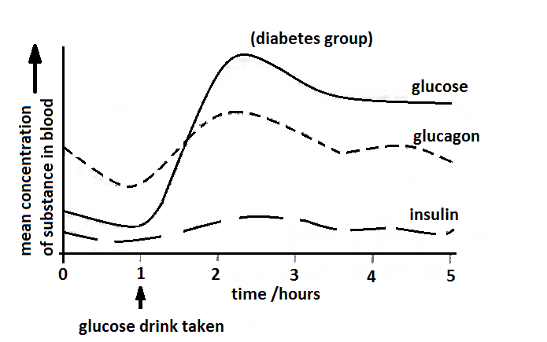

Suggest what might happen to the blood glucose concentration of Group B if they have no food for the next 24 hours.

Glucose concentration decreases (1)

(1 mark)

1. If one of the members from Group B collapsed and was given insulin, describe two (2) intra-cellular processes that will occur in the liver.

Glucose stored as glycogen (1)

Glucose used in respiration (1)

(2 marks)

**Question 37 (13 marks)**

Zika virus (ZIKV) is responsible for major unprecedented outbreaks and epidemics and has been causally associated with foetal microcephaly. The development of a safe and effective ZIKV vaccine is now an urgent global health priority. The following experiment shows the use of a type of vaccine that protects against ZIKV in rhesus monkeys. A purified inactivated virus vaccine, VRC 5288, induced ZIKV-specific neutralising antibodies and completely protected monkeys against ZIKV strains from both Brazil and Puerto Rico.

Before the clinical development of ZIKV vaccines, the following investigation was conducted to determine the relationship between the number of correct dosages of the ZIKV vaccine and its effectiveness to produce an immune response or immunogenicity. Immunogenicity is measured by the amount of neutralising antibodies (Ab) produced.

Method:

1. There are four groups of six monkeys (specifically Rhesus macaques).
2. Group A received a single 1 mg dose of VRC 5288 at week 0.
3. Group B received a single 1 mg dose of VRC 5288 at week 0 and another 1 mg dose of VRC 5288 at Week 4.
4. Group C received a single 4 mg dose of VRC 5288 at week 0 and another 4 mg dose of VRC 5288 at Week 4.
5. Group D is the control group.
6. Every week, the monkeys’ blood sera were assayed by ELISA [Enzyme Linked Immunosorbent Assay] for ZIKV neutralising antibodies (Ab). The average Ab concentration for each group is given in Table 1.

Eight weeks after immunisation, all groups of animals were challenged subcutaneously with a ZIKV strain from Puerto Rico, PRVABC 59. Blood samples were collected daily for polymerase chain reaction (PCR) analysis of the ZIKV genome copies in plasma to determine virus load (viremic level).

**Table 1**

|  |  |  |  |  |
| --- | --- | --- | --- | --- |
|  | Average antibody concentration - arbitrary units/ genome copies per mL | | | |
|  | Group A  VRC 1 mg x 1 | Group B  VRC 1 mg x 2 | Group C  VRC 4 mg x 2 | Group D |
| Week 0 | 0 | 0 | 0 | 0 |
| Week 1 | 0 | 0 | 0 | 0 |
| Week 2 | 2.00 | 2.50 | 2.75 | 0 |
| Week 3 | 3.25 | 3.50 | 3.75 | 0 |
| Week 4 | 3.50 | 3.75 | 4.25 | 0 |
| Week 5 | 3.75 | 4.00 | 4.50 | 0 |
| Week 6 | 3.50 | 4.25 | 4.75 | 0 |
| Week 7 | 3.25 | 4.50 | 5.00 | 0 |
| Week 8 | 3.00 | 4.25 | 4.75 | 0 |
| Viremic Level  (Presence of virus in the blood) after challenge | High  +++ | Negligible  - | Negligible  - | Very High  +++++ |

1. Based on the data given in Table 1, plot a graph to show the relationship between the binding antibody concentrations for each group over an eight-week period post vaccination period. (6 marks)

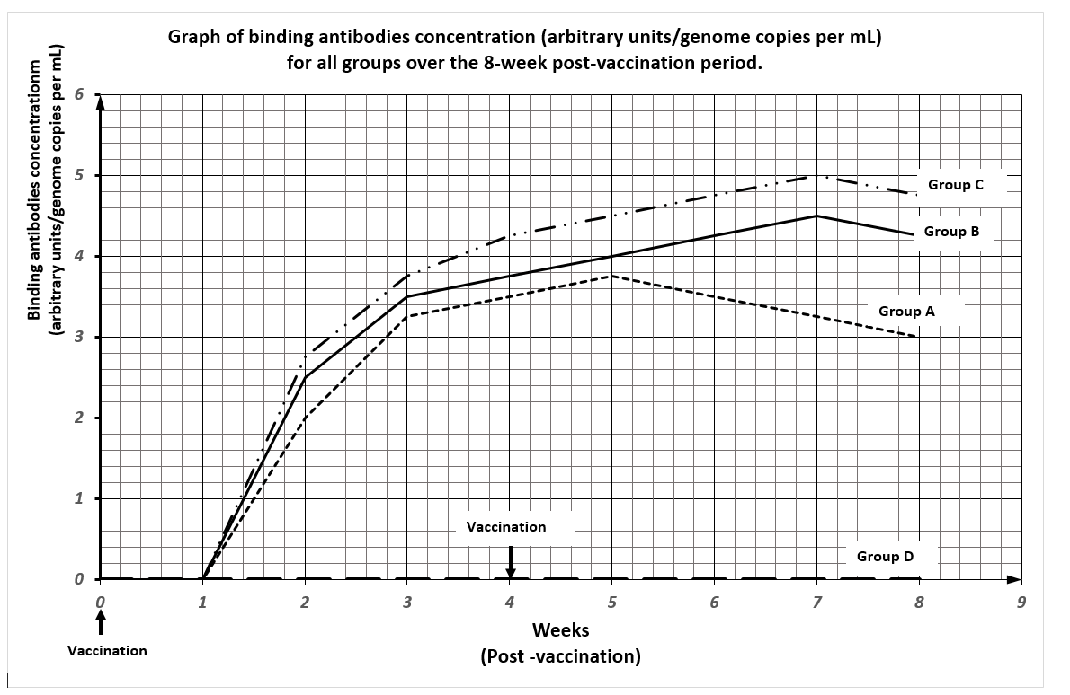

|  |  |
| --- | --- |
| 1 mark | Title (relating the independent and dependent variables) |
| 1 mark | Correctly labelled x axis with units |
| 1 mark | Correctly labelled y axis with units |
| 1 mark | Suitable scale |
| 1 mark | Legend/Key |
| 1 mark | Accurate plotting |

1. What role does a placebo play in a scientific experiment?

Control/comparison (1)

(1 mark)

1. State one factor involving the monkey’s blood serum that the scientists would have to determine before they begin the experiment.

Initial level of neutralising antibodies in the monkey’s serum (1)

(1 mark)

1. Describe the immune responses of the groups being investigated.

* All ZKV vaccine groups had significantly higher antibody responses than the control group (1)
* Monkeys that received a single dose of 1mg of VRC5288 had significantly lower antibodies than macaques that received two doses of vaccine (1)

(2 marks)

1. What could be the conclusion of this investigation?

Monkeys that received two 4mg doses or 1mg doses of VRC 5288 were largely protected by the Zika virus. It is essential that monkeys receive two doses for full efficacy (1)

(1 mark)

1. Scientists in this investigation are now working on evaluating both protein-based, whole inactivated ZIKV vaccines and live-attenuated vaccine approaches. Explain the difference between these two vaccine approaches.

* Whole inactivated vaccines – contain complete non-virulent micro-organisms inactivated with chemicals (1)
* Live-attenuated vaccines – utilises live micro-organisms with reduced virulence, that is with a reduced ability to produce disease symptoms so that the immunised person does not contract the disease but makes antibodies against the antigens (1)

(2 marks)

**Question 38 (10 marks)**

***Refer to the following table to answer the following question.***

Table 2: Relationship between humans and great apes using DNA differences

|  |  |
| --- | --- |
| Primates being compared | DNA difference (%) |
| Human - Chimpanzee | 1.2 |
| Chimpanzee - Gorilla | 1.2 |
| Human - Gorilla | 1.6 |
| Chimpanzee - Orangutan | 1.9 |
| Human - Orangutan | 2.5 |
| Gorilla - Orangutan | 2.5 |

* 1. Use the information given in the table above to construct a phylogenetic tree to illustrate the evolutionary relationships of the great apes and humans.

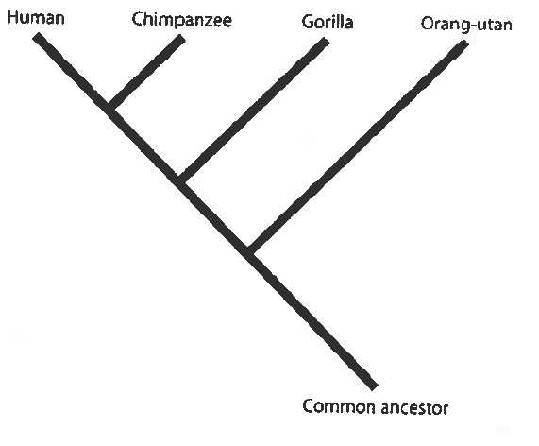

* 1 mark for indicating three species in the right order.
* 2 marks for indicating four species in the right order.
* Full marks for indicating all species in the right order using an appropriate phylogenetic tree format. (Distance between the species is not that critical.)
  + - 1. marks)
  1. The drawings below show some stone tools. A1 and A2 belong to a different tool culture from B1 and B2.

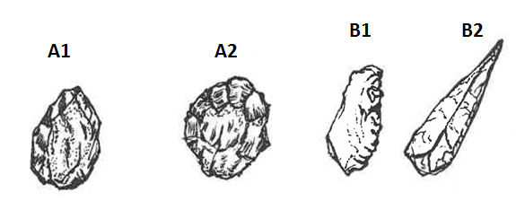

**Figure 10**

1. Identify the tool culture of B1 and B2.

Mousterian Tool Culture (1)

(1 mark)

1. Give two pieces of evidence to suggest that A1 and A2 are older than tools B1 and B2.

* A1 and A2 – simple stone tools, sharp flakes observed made by hitting with a rock (1) / larger flakes removed / few flakes removed
* B1 and B2 – more refined, using stones, bone/antler/ flint rather than pebbles / whole tool shaped (1)

(2 marks)

1. Suggest two possible uses of tools such as A1 and A2.

* Chopper for cutting meat or cracking bones to obtain marrow (1)
* Scraper to remove waste materials / clean animal hides (1)

(2 marks)

1. Describe how tools B1 and B2 might have been made.

* Stone flakes are made by breaking flakes off a stone core
* Use of a softer hammer of bone or antler to refine the flake
* Pressure flaking to sharpen knife edge

(any 2 of the above – 1 mark each)

(2 marks)

**Question 39 (10 marks)**

The images below show front, side and bottom views of the skull of an Australopithecine.

**Figure 11**

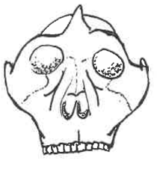 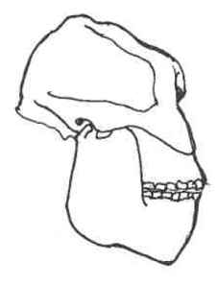 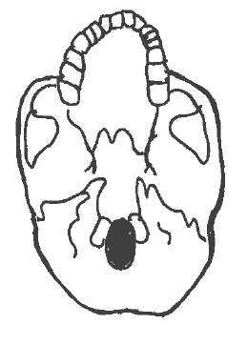

1. Describe how an examination of the skull above could give evidence about the posture, locomotion, brain size and diet of an Australopithecine.

* Front view – Posture - Presence of zygomatic arch & nuchal crest for muscle attachment suggests presence of robust jaw muscles & neck muscles to hold up a forward-heavy face – **posture – stooped**. Almost erect stance (1)
* Side view – Locomotion - shows a nearly central position of foramen magnum - indicate an upright stance and **bipedalism. (1)**
* Side & front view – Brain Size - indicates a relatively small cranial capacity/ **brain size** (1)
* Side view – Diet - Presence of robust cheek bone and massive jaws (high degree of prognathism) suggests a diet that comprises **tough fibrous food.**

[Side view & front view – suggest parabolic dental arcade and teeth that permit grinding movements and for chewing] (1)

1. marks)
2. Compare the posture and brain size of an Australopithecine and a gorilla. State the differences between the early hominin and great ape.

|  |  |  |
| --- | --- | --- |
|  | **Australopithecine** | **Gorilla** |
| **Posture (both correct - 1 mark)**  **Brain Size (both correct - 1 mark)** | Erect  440 – 480 cc / Small | Quadrupedal  About 450 cc / Small |

(2 marks)

1. The Laetoli footprints (a set of footprints) found in volcanic ash in Tanzania are 3.56 million years old and are believed to have been made by *Australopithecus afarensis*.
2. Outline two methods by which it would be possible to determine how long ago the Australopithecine lived.

* Potassium-argon dating (1)
* Analysis of stratigraphy (1)

1. marks)

ii. State the assumptions that must be made using these two methods of dating.

* Potassium-argon dating relies on suitable material such as volcanic lava being present/ rocks of similar age/ covered in lava (1)
* Layers laid down in the order they appear/ layers further down are older/ at the top are younger/ layers in different areas with similar layers are of the same age (1)

(2 marks)

**END OF SECTION TWO**

**Question 40 (20 marks)**

One of the most exciting discoveries in recent years is the fossil skeleton of a new species, *Homo floresiensis,* found in the Liang Bua Cave on the Island of Flores in Indonesia by Australian and Indonesian palaeontologists. The discovery was announced to the world in 2004, and the fossil, nick-named `the hobbit’, lived as recently as 18 000 years ago until a massive volcanic eruption decimated them. The fossil skeleton stands only one metre tall and has a small brain size of 380 cm³. It was found with stone tools and the remains of a pygmy form of extinct elephants *Stegodon* and burnt remains of smaller animals.

1. Describe the physical features of this fossil skeleton that would place it in the genus `*Homo*’. Also identify any discovered features that challenge our understanding of the evolution of the genus `*Homo*’. (8 marks)

|  |  |
| --- | --- |
| Physical Features of `Homo’ - *at least 2 features of bipedalism to be mentioned* | 6 |
| * Relatively lightly boned (less robust) * Reduced jaw size * Reduced prognathic face * Reduced canine teeth * **Features indicating bipedalism (central positioning of foramen magnum of the skull/ S-shaped spine/ broad pelvis, foot arches – transverse & longitudinal)** |  |
| Challenges (any 2) | 2 |
| * Small brain of 380 cc – other homo species 0 > 800 cc [1] * Cooking/tools present which suggests advanced culture not expected of 380 cc brain size. [1] |  |

1. Describe the tool culture associated with Homo Erectus (4 marks)

|  |  |
| --- | --- |
| Tools (any 4 of the following) | 4 |
| * Acheulian tools * Flaked all round the edges (first in one direction & then in the other) – bifacial cutting edge * Teardrop in shape * Used as hand axes for chopping/scraping (butchering food) * Made from stone and bone |  |

1. Describe how the `*Homo*’ genus is different from the *Australopithecines.* (8 marks)

|  |  |
| --- | --- |
| ***Homo*** (any 4 of the following) | 4 |
| * Taller and larger in stature * relatively large brain capacity * no sagittal crest * less heavy-boned than Australopithecines * reduced jaw size and * made and use tools |  |
| ***Australopithecines*** (corresponds to each of the 4 of the following) | 4 |
| * smaller in size * relatively smaller brain-case * sagittal crest in some forms * forward projecting face (shows distinct prognathism) * more robust body form |  |

**Question 41 (20 marks)**

1. A minute sample of DNA has been obtained from an individual for paternity testing and to establish any possible link with a rare genetic disorder.

i. Outline two **named** techniques in biotechnology that are carried out before proceeding to DNA sequencing of the genome. (11 marks)

ii. Rapid developments in genomic testing methods have made the sequencing of a person’s DNA faster and cost-efficient. List some ethical issues involved in the use of the genomic information as a `lifetime health resource’. (3 marks)

|  |  |
| --- | --- |
| Polymerase Chain Reaction - named | 1 |
| * Denaturation – double-stranded DNA is separated into single strands by heating to 96° C. * Annealing – use of Taq polymerase, primers, free nucleotides to complete DNA replication whilst cooled to 72°C. * Elongation– Process is repeated with newly formed DNA strands – thermos-cycling of heating and cooling to produce 2ⁿ copies for n cycles. * End result – Amplification of DNA | 4 |
| Gel Electrophoresis – named | 1 |
| * DNA is cut by restriction enzymes to fragments of varying size * DNA is micro-pipetted into wells on a gel plate & subject to an electric current in a GE cell * Being negatively charged, DNA moved towards the positive electrode * Shorter, lighter DNA fragments travel faster than the longer, heavier DNA fragments. * A pattern of DNA bands can be detected when DNA treated with chemicals fluoresce under ultra violet light and photographed to show the DNA profile. | 5 |
| Ethical Issues (any 3 or suitable responses) | 3 |
| * Genetic information is hereditary so knowledge of an individual’s own genome has implications for members of the family * Legislation is needed to ensure that there is no discrimination on the basis of genetic information * Genetic procedures as such are still costly – not accessible to all -, and there is no easy answer as to who should pay for them. * Our ability to interpret genomic information is still at an early stage. Even for those whom we know, with certainty, have a genetic condition, it can be challenging to identify a specific disease-causing gene change. We do carry many different types of genetic variants. So genomic testing can lead to incorrect or over-diagnosis. * Genomic information has the potential to influence the direction of human evolution because human intervention determines which embryos to implant and which to discard after identifying the genome. Sometimes the stem cells of healthy embryos are used as donor cells to generate tissue to treat individuals with genetic abnormalities. * When this occurs, the affected individual, who might otherwise die, may lead a relatively healthy life, even reaching reproductive age—then the defective alleles may be passed on to offspring and the genetic disorder is perpetuated. * Other issues surround the privacy and disclosure of genetic information and the storage or future use of test samples and data etc |  |

1. Define gene therapy and cell replacement therapy. For each of these techniques, state an example of its application and discuss any ethical issues raised by this kind of human intervention. (6 marks)

|  |  |
| --- | --- |
| Definition | 1 |
| **Gene therapy** is the inserting of the normal (healthy gene) for a faulty gene to bypass its effects. [1] |  |
| Application | 1 |
| It works well with single gene disorders such as cystic fibrosis/ Huntington Disease/ muscular dystrophy / sickle cell anaemia. [1] |  |
| Ethical Issue(s) | 1 |
| * While gene therapy is used to treat a patient, it also raises some ethical issues. It does not alter the genotype of the affected individual, who can still pass the defective gene on to offspring, thereby perpetuating the genetic disease in the population. * Viruses are typically used as the vector or delivery system for delivering the gene in gene therapy to the affected tissue in a patient—however, there is no guarantee that the virus used will not itself be the subject of a defense response by the body’s immune system. There may be unforeseen side-effects resulting from gene therapy. * Unknown long term effects on individuals and on subsequent generations |  |

|  |  |
| --- | --- |
| Definition | 1 |
| **Cell replacement therapy** is a treatment which made use of cell culturing to replace damaged cells with healthy ones. [1] |  |
| Application | 1 |
| EXAMPLE – Cell replacement therapy for the nervous system is used to treat neurodegenerative disorders such as Parkinson’s / Alzheimer’s. [1] |  |
| Ethical Issue(s) | 1 |
| Use of embryonic stem cells is controversial and raises a number of ethical questions  -long term effects to be explored  - cost and affordability – not accessible to all – who pays?  - moral issue of using `embryos’ tantamount to taking `life’ |  |

**Question 42 (20 marks)**

1. The Rotary Beachside Festival Fun Run in Safety Bay, Rockingham WA on 26 March 2017 was scheduled to start in the morning at 9 am. The Fun Run was to be a 21km half marathon or 10 km or 5 km fun run, and the competitors had 4 hours to finish the event. The event organisers took into account the expected weather conditions when scheduling this event to allow the athletes to perform in the most suitable conditions.

The expected weather conditions were as follows:

* mean maximum daily temperature: 23.4oC
* mean 9 am temperature: 16.9 oC
* mean 9 am humidity: 62%
* mean 3 pm temperature: 22.7 oC
* mean 3 pm humidity: 52%

During this event, the athletes needed to maintain their homeostasis of body temperature and body fluid concentrations. Outline these two homeostatic mechanisms and the interactions between them in an athlete participating in this event during the given expected weather conditions for March in Rockingham, WA. (12 marks)

|  |  |
| --- | --- |
| Thermoregulation | 6 |
| * Gain of heat directly from the environment through radiation and conduction as well as heavy exercise * Rise in skin or core body temperature (stimulus) detected by the thermoreceptors 🡪 hypothalamus * Hypothalamus co-ordinates responses that increases heat loss through the parasympathetic nerves of the autonomic nervous system * Sweating increases (sweat cools by evaporation); will become more profuse with rising humidity * Blood flow to skin (vasodilation) increases to increase heat loss * Negative feedback to restore body temperature to normal |  |
| Body Fluid Regulation | 6 |
| * Water concentration of blood plasma decreases/ osmotic pressure of blood increases; mouth becomes dry * Osmoreceptors in the thirst centre of the hypothalamus are stimulated, * Creating sensation of thirst * Person responds by drinking water / cooling liquids * Water drunk is absorbed into the blood from the alimentary canal system * Water leaves the blood, the intercellular fluid and extracellular fluids return to normal concentrations * Increase ADH production, more water reabsorbed in the kidney nephrons to replace water loss |  |

1. Homeostasis is vital for the body to keep functioning efficiently. Describe fully how homeostasis is achieved with respect to an increase in carbon dioxide levels. (8 marks)

|  |  |
| --- | --- |
| Gas Concentrations – Carbon Dioxide | 8 |
| * The level of carbon dioxide in the blood increases * Associated change in the H+ ion concentration/pH of the blood * Detected by peripheral chemoreceptors located in the aortic & carotid bodies * Detected by central chemoreceptors located in medulla oblongata * Chemoreceptors transmit nerve impulses to Respiratory centre in medulla * Effect the intercostal muscles and diaphragm/respiratory muscles * Phrenic nerve to diaphragm / intercostal nerve to intercostal muscles * Change rate of contraction / increase rate of contraction * Change rate of breathing/increase rate of breathing * Negative feedback / level of carbon dioxide in the blood decreases   NB: Can use a feedback loop to display the above information |  |